Name: - Ishan tejasbhai thakkar

ID NO: - 21EL032

Division: - 04

Year: - 2023-24

Subject: - Digital System Design (3EL42)

Branch: - Electronics (EL)

Assignment: - 2

Q-1: -Design 4-bit Ripple Carry Adder with the help of 1-bit adder

VERILOG CODE:-

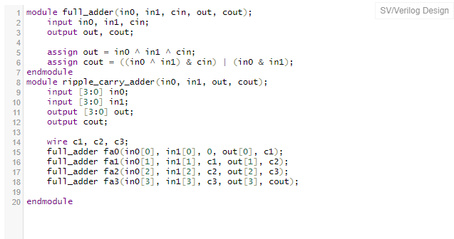

TEST BENCH:-

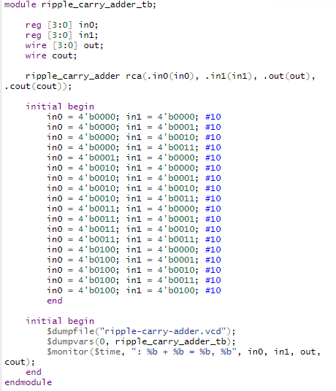

OUTPUT: -

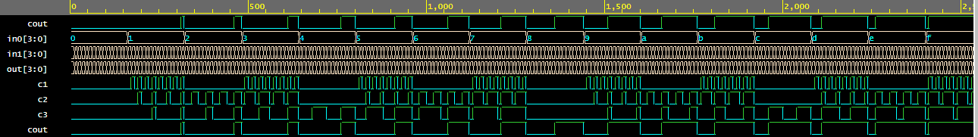

Q-2: - Design D-flipflop and reuse it to implement 4- bit Johnson Counter

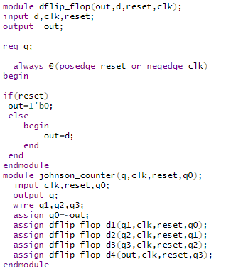

TEST BENCH:-

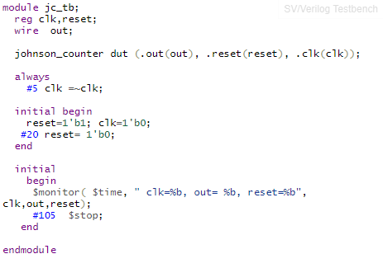

OUTPUT:-

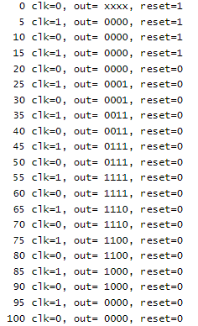

Q-3: - Reuse 2:1 Mux code to implement 8:1 Mux

VERILOG CODE:-

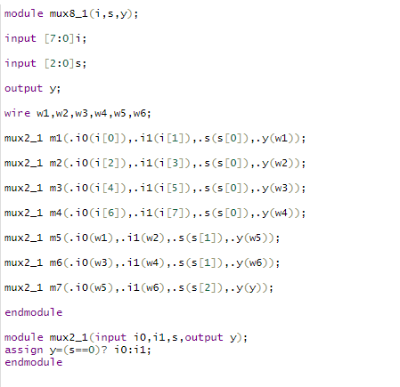

TEST BENCH:-

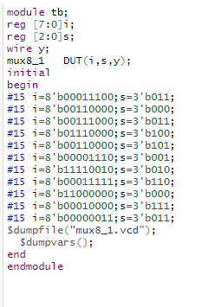

OUTPUT:-

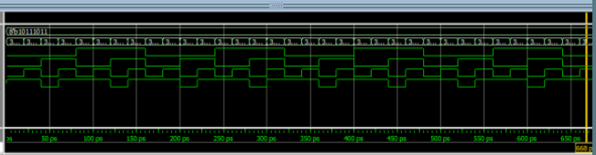

Q-4: - Design a Full Subtractor with Gate Level Modelling Style. (Use primitive gates)

VERILOG CODE:-

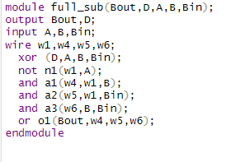

TEST BENCH:-

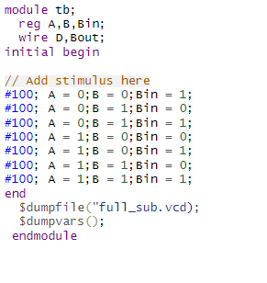

OUTPUT:-

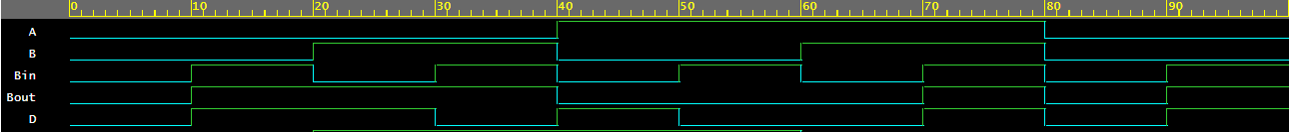

Q-5: - Design a 2X4 decoder using gate level modelling

VERILOG CODE:-

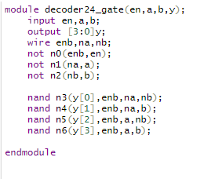

TEST BENCH:-

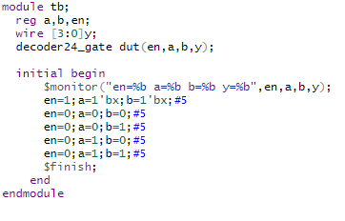

OUTPUT:-

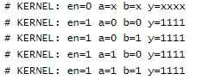

Q-6: - Design a 4x1 mux using operators. (Use data flow)

VERILOG CODE: -

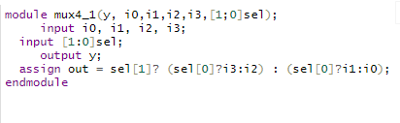

TEST BENCH: -

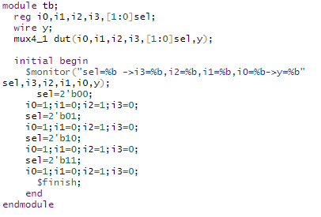

OUTPUT: -

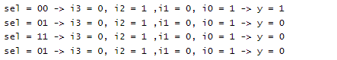

Q-7: - Design a Full adder using half adder.

VERILOG CODE:-

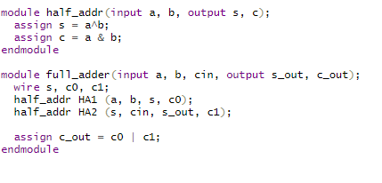

TEST BENCH: -

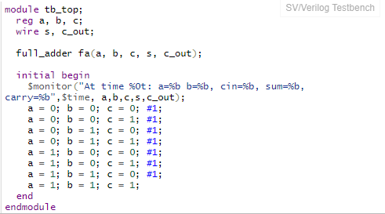

OUTPUT: -

